2022mc58

task1

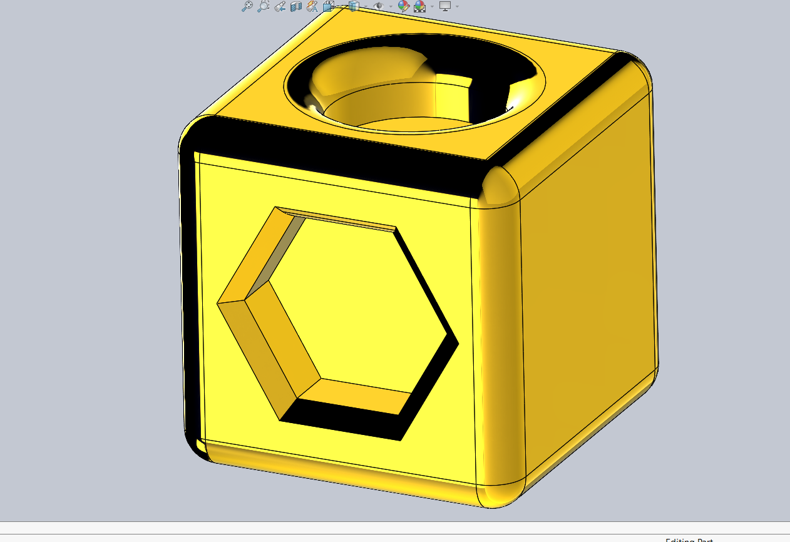

Task2

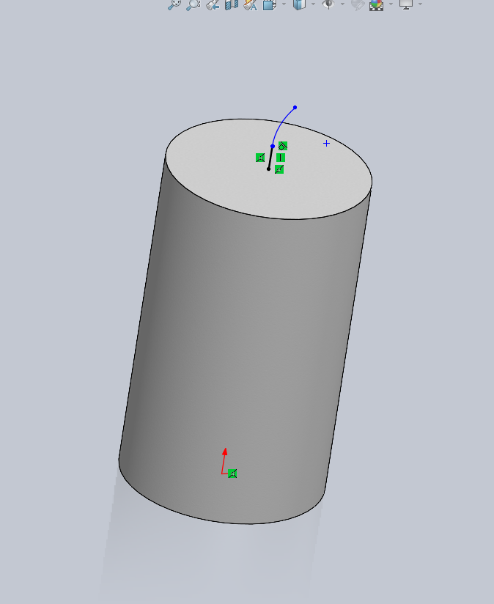

Task3

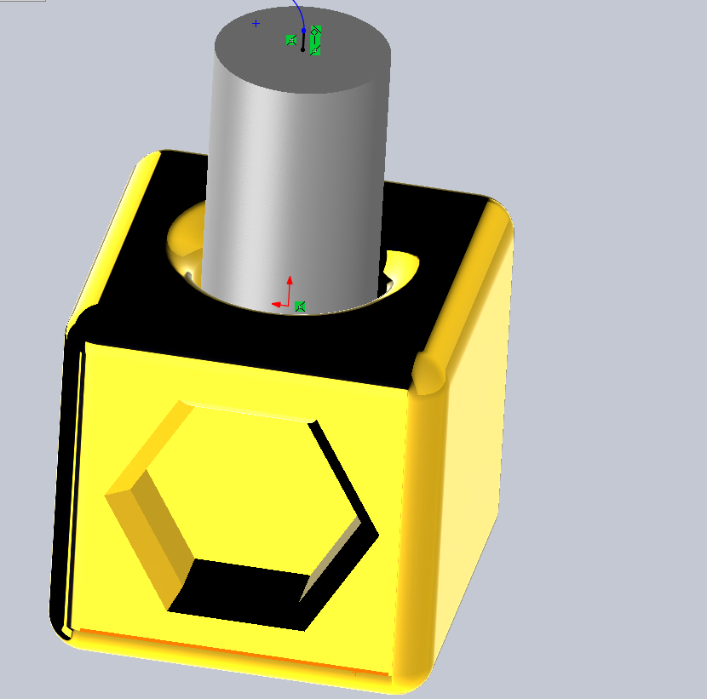

Procedure part1

First – sketch

Second – extrude

Third – face select

Fourth – sketch

Fifth – extrude cut

Six-extrude cut

Seven-face select

Eight-extrude cut

Nine-sketch

Procedure part2

First – sketch

Second – extrude

Third – face select

Fourth – sketch

Procedure part3

First – assembly

Second – select parts

Third – mate select

Fourth –select ,ate surfaces

Fifth – enter